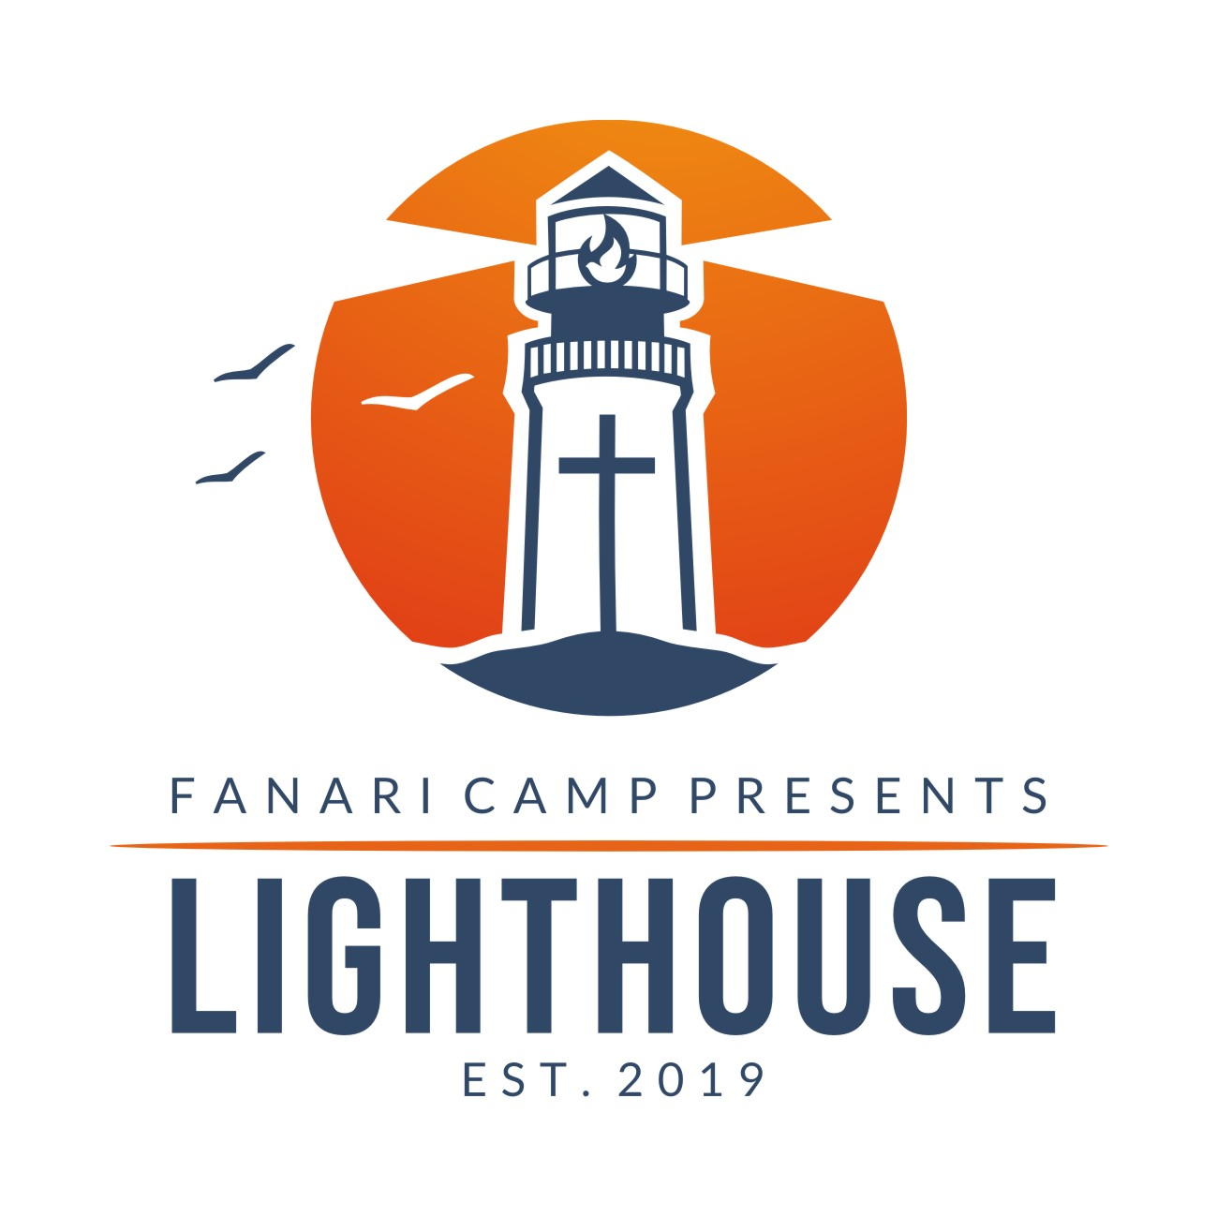

Greek Orthodox Metropolis of Chicago
Lighthouse 2023 | June 24-July 1 | Carroll University, Waukesha, Wisconsin
Dear Registrant,
Thank you for registering for Lighthouse! We look forward to a week of exploring our three themes: Ignite. Illumine. Radiate. We are confident that you will leave Lighthouse with a deeper sense of our faith, community, calling, and our Christian Family as you prepare for the unchartered waters of college and your career.
Before your stay at Lighthouse, please log into your CampDoc account and make sure that you fill out the entire Health Profile. This allows us to care for all participants during their stay, especially in the case of any emergency.
Please acquaint yourself and yourself with the literature below to familiarize yourself with our Rules and Regulations, Community Covenant, and other pertinent information about Lighthouse. A packing list and more detailed information regarding program activities will be sent about six weeks prior to the program.
As COVID realities continue to shift, we will be refining our safety measures and will send detailed information regarding our protocols six weeks prior to the program as well.
In Christ,

Fr. Kosmas Kallis
Director, Lighthouse Camp

Location:
- Lighthouse is located at Carroll University, Waukesha, Wisconsin
- Drop-off for Lighthouse will be at the Prarie Hall, 304 W College Ave, Waukesha, WI
- For more information on the facility and directions, visit carrollu.edu
Drop off & Pickup:
- Check-in on Saturday, June 24, 2023 will be anytime from 3-4pm (snacks provided until Dinner time)
- Please, unload your belongings and check in at Prairie Hall (look for the orange and blue balloons and Lighthouse banner)
- Campers will be screened by our medical staff, turn in any Medications, technology and receive their housing assignment
- Check-out is on Saturday, July 2 from 2-3pm in the same location (we will eat brunch)
Medication
- If you are sending any medications prescription or not with your child to camp, please enter them in the “Medications” section of the online registration on CampDoc
- Prescription medications must be in original bottles with Pharmacy label
- Non-Prescription meds must be in original box/ bottle (No pill boxes)
- Place all medicines in one plastic Ziploc Bag and label with camper’s name to be turned in to our Medical Staff upon your arrival at Lighthouse Camp
- No need to send common over-the-counter medications, (Tylenol, Advil, Allergy meds, etc.) as our infirmary does supply them
Other Notes:
- No cell phone policy: we are focusing in on building community and our goals of Lighthouse; to do that, we will be requiring campers to turn in their cell phones for the week. Phones will be returned to campers at the close of the program on Saturday just prior to pick-up. If you need to contact your child during the program, you can call our office number at any hour of the day: 262-237-8562
- Any questions about Lighthouse can be emailed to: office@fanari.camp
- For technical support with your online registration on Campdoc.com, please email support@campdoc.com or call 734-636-1000

Lighthouse Rules & Regulations
The following rules concerning life at Lighthouse are intended for all participants. Like anything, these rules are set to help us achieve our goals at Lighthouse, as opposed to limiting us. Please step in to these rules as an opportunity to Ignite, Illumine, and Radiate!
PLEASE READ AND AFFIRM THE FOLLOWING INFORMATION WITH YOUR CHILD:
- We’re setting aside our phones for the week. Let’s focus in on our goals instead. Hopefully someone owes you for keeping streaks.
- Technology for music will be provided by our staff. Feel free to bring speakers!
- We are in a nut-free facility at Lighthouse. Please, DO NOT pack any food products/snacks that may contain nuts or were made in a facility that processes nuts.
- All campers should be properly dressed at all times. Christian modesty should be taken into account when packing for the week. Inappropriate clothing (revealing shorts, strapless tops, controversial or offensive T-shirts and pants/shorts) is NOT permitted. For our beach day, one-piece swimsuits are required.
- Dress for Divine Liturgy is Sunday church appropriate. Young men should wear slacks/dress shirt, tie (optional) and dress shoes. Young ladies should wear a blouse & skirt or dress, which is modest in length, and dress shoes.
- Bringing and/or use of any type of alcohol, illegal drugs, tobacco (including chewing tobacco or dip), e-cigarettes of any kind, firearms, or any kind of weapon (knives/switchblades) IS PROHIBITED AND GROUNDS FOR IMMEDIATE DISMISSAL. The possession or use of any fireworks is forbidden and are illegal in the state of Wisconsin. The use of lighted candles and/or anything that produces a flame is prohibited in the cabins.
- Water balloons, squirt guns and shaving cream (other than for the purpose of shaving) are NOT allowed.
- No camper may leave the group at any time during Lighthouse.
- Respect for all property at all times, includes housing, beds, mattresses, outdoor and indoor facilities. Defacing of property will NOT be tolerated. Carving or writing on buildings, lawn furniture, room furniture, and trees causes permanent damage and will not be tolerated. Anyone causing damage to property will be required to pay for the damages and parents will be contacted for further disciplinary action.
- Camp equipment or furniture should not be removed from the buildings where they were originally found or belong.
- The use of portable music devices such as MP3 players and iPod’s that are not Wi-Fi enabled are allowed, but must be used only during free time or while in the cabin. All gaming systems and handheld devices, TV’s/DVD players, and large boom boxes are not allowed.
- Participants may only enter the housing space that they are assigned. At no time should two people of opposite gender be in another’s dormitory.
- No visitors are allowed during the camp program.
- We strongly recommend not bringing anything of value or importance, i.e., jewelry, apparel, etc. Lighthouse will not be responsible for lost or stolen items.
- Fighting, abusive language or swearing and bullying will not be tolerated by campers or staff and can result in IMMEDIATE DISMISSAL.
Community Covenant: I will at all times...
Conduct my behavior in a responsible, respectful and Orthodox Christian ethos.
Maintain abstinence from the possession or use of alcohol, illegal drugs, tobacco, fireworks, firearms, or any kind of weapon.
Remain at my designated group location unless given specific permission by the appropriate designated authority.
Remain on camp property at all times.
Respect all property including housing, athletic equipment, outdoor and indoor facilities. I agree that I will be financially responsible for any damage incurred.
Maintain respect for the Clergy, Counselors, and Staff or other persons responsible for directing programs and/or activities.
Maintain demeanor, which does not encourage inappropriate sexual behavior nor participate in such activity.
Understand that it is a privilege to be a participant at camp and will represent myself in a Christ-like manner.
Be held personally responsible for all of my actions.
Understand that if my behavior is not becoming of an Orthodox Christian, I will be asked to leave Lighthouse Camp.
Adhere to all the Rules and Regulations stated above.
By registering and attending Lighthouse Camp, it is understood that all campers accept the Community Covenant.

