Dear Chicago Metropolis Family,
Each Memorial Day Weekend, over 1,700 Metropolis Youth and 2,000 Spectators from 6 States and over 35 Parishes come together in fellowship, fun, and Christian competition for one of the Chicago Metropolis’ largest events: the Junior Olympics. Over this weekend event, these members of our Orthodox Church compete amongst their fellow brothers & sisters in Christ in 10 team sports and over 40 individual events; developing their character and ethos in the Orthodox Tradition.
Our Church Fathers often described our spiritual life as similar to that of an athlete’s. In order to be the best we can, we must practice and many times we will struggle. But it is through this practice and struggle that we (and our faith) can strengthen in God. The Metropolis of Chicago’s Junior Olympics provides this lesson to its youth each year, a safe place to struggle and grow in our faith and relationships surrounded by peers, priests, family and friends to strengthen us as we grow in the Lord.
As one can expect, putting on an event of this scale is not easy. It takes time, effort, and resources from across the Metropolis to create this experience for our youth. But we believe the experiences had by our youth at the Jr. Olympics last a lifetime and keep them in the life of our Church.
This is why we are asking for your financial and volunteer support.
This year, we invite you to become a part of this youth ministry by being an event sponsor to enable the Olympics to once again take place. Your gift will help us grow our ministry by: (1) developing more programs; (2) reducing registration fees to include more participants and; (3) offering registration aid to families who can’t afford them. Do not hesitate to contact me at frchris@ssch.us for more information or directions on how to donate.
We thank you for your investment in the physical, social and spiritual development of the youth of this Metropolis and wish you all of God’s blessings.

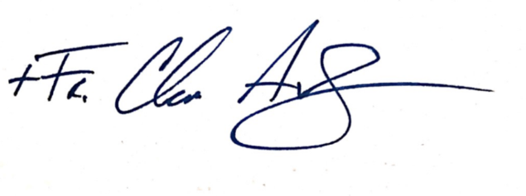
In His service,

Rev. Fr. Chris Avramopoulos
Director, Jr. Olympics

Individual Events – Sponsorship $500
Please check the event(s) you would like to sponsor
- Tavli/Backgammon
- Chess
- Checkers
- Swimming (15 event sponsorships available)
- Track/Field (20 event sponsorships available)
- Tennis
- Table Tennis
Team Events - Sponsorship $1,000
Please check the event(s) you would like to sponsor
- Co-ed Softball (1 event sponsorship available)
- Boys & Girls Volleyball (2 event sponsorships available)
- Co-ed Basketball (2 event sponsorships available)
- Soccer (4 event sponsorships available)
Venue Banners – Sponsorship $5,000
Please check the venue(s) you would like to sponsor

- Boys Volleyball Gym (STAGG)
- Girls Volleyball Gym (STAGG)
- Softball Fields (SSCH)
- Junior Basketball (SSCH GYM)
- Senior Basketball (STAGG GYM)
- Table Tennis Room (SSCH GRAVEN HALL
- Carpet Room (STAGG)
- Tennis Courts (STAGG)
- Swimming Pool (STAGG)
- Main Track/Field (STAGG)
- Main Stage (STAGG)
- Stagg Cafeteria
- Stagg Outdoor Grills (2)
- SSCH Cafeteria (Main Lobby)

Grand Sponsorships - $10,000
- Check here to be this year’s single Grand Sponsor
Please make your check out to: Greek Orthodox Metropolis of Chicago – Y2AM
Mail to: 555 E. Butterfield Road, Suite 201, Lombard, IL 60148
Thank you!

